RESEARCH OUTPUTS MANAGEMENT SYSTEM (ROMS)
A basic guide to entering and maintaining your research activities

Table of Contents

Login to the ROMS 2
Change Password 4
Structure of the Guide 4

Section 1: Entering & Maintaining Your Research Outputs & Activities 5
- References – My Research Outputs 5
    - To Add New Research Outputs 6
    - To Edit Research Outputs Already Entered 8
    - To Upload Research (Digital) Objects/Files 9
  - Peer Esteem 10
1.2.1 To Add New Peer Esteem 10
1.2.2 To Edit an Existing Peer Esteem 11
1.3 Contributions to Research Environment 11
1.3.1 To Add New Contribution 12
1.3.2 To Edit an Existing Contribution 12
1.4 Reports 13

Section 2: Preparing Your PBRF Evidence Portfolio 14
  - Selecting the Nominated Research Outputs 14
  - Editing and Ranking the Nominated Research Outputs 15
  - Selecting the Top 30 Research Output Items 16
  - Selecting the 30 Peer Esteem Items 16
  - Selecting the 30 Contributions to Research Environment Items 16
  - Panels 16
  - Special Circumstances 17

Appendix 1: Research Output Types 19
Appendix 2: Peer Esteem and Contributions to Research Environment 20
Appendix 3: Peer Review Panels and Subject Areas 26
Appendix 4: Special Circumstances 28
The ROMS will permit:
- the collection of all research outputs and activities;
- researchers to prepare their PBRF Evidence Portfolios.

Login to the ROMS

Go to the Research and Postgraduate Studies page of Pou Tukutuku (The Nest) and click on the ROMS link
OR
Using an Internet browser enter the following URL
http://unitec.roms.intuto.com/

This will open the login screen shown below

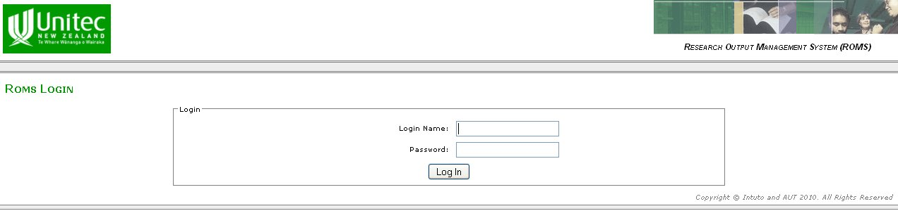

Login Name Enter your Unitec user name
e.g. jbloggs

Password StaffID
e.g. 1546787 for Joe Bloggs
e.g. 2598765 for Fred MacDonald

Timing out The system will time out after an hour if there is inactivity. Any data not saved will be lost.

Support If you encounter any problems with ROMS, the first point of contact is Katie Jones, Research Advisor, who will escalate the problem if it cannot be resolved

After Login you will be presented with the following screen:

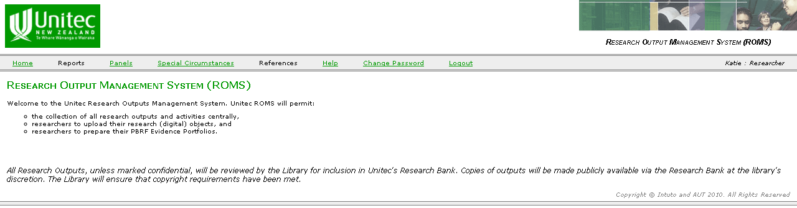
The MENU bar is the key to navigation around the system. These include:

Reports Research outputs (only those in Entry Completed status) and activities by year;
PBRF Evidence Portfolio in MS Word or XML formats.

Panels This is a PBRF specific item where you nominate your Primary Panel, Secondary Panel, Subject Area, Keywords for Subject Area and other information relating to your research area. If you are unclear about which panel or subject area to nominate, please consult your Department Research Committee or Head of Department.

Special Circumstances This is a PBRF specific item. Special Circumstances relate to some impairment or impediment that has affected the development of research outputs and your peer esteem or contribution to the research environment components of the PBRF. You are permitted to supply up to 3 special circumstances for consideration and their level of seriousness (i.e. extent to which the case have impaired or impeded your production research outcomes).

References Permits the maintenance of your research outputs, peer esteem (PE) and contributions to research environment (CRE) components of the PBRF. It also allows you to provide information about your Top 4 Nominated Research Output (NRO) – i.e. your contribution and reasons for choosing as one of your NROs. The NRO, PE and CRE are PBRF specific items.

Help Invokes the User Guides.

Change Password Allows password to be changed.

Logout Takes you back to the Login Screen.

Change Password

From the Menu Bar, click Change Password will bring up the following.

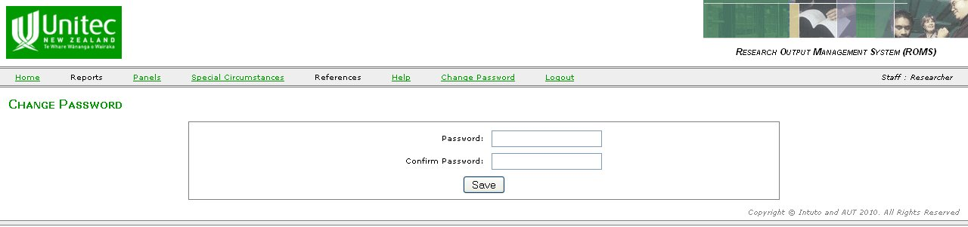
Password Enter the new password

Confirm Password Re-enter the new password

Structure of this Guide

There are 2 sections to this guide:

Section 1 – Entering & Maintaining Your Research Outputs & Activities

This section covers what to enter and how to edit/maintain what is already in the ROMS.

Section 2 – Preparing Your PBRF Evidence Portfolio (EP)

This section outlines what you need to do in ROMS to prepare your EP.
Section 1 – Entering & Maintaining Your Research Outputs & Activities

1.1 References – My Research Outputs

Research outputs reported and verified from 2006 to 2009 have been uploaded onto the ROMS. As these records have been reported and verified, they are all “locked-down” (i.e. you will not be able to edit these records).

If you find that your outputs from these years are not listed or are incorrect, please contact your department’s ROMS representative for assistance.

From the Menu bar, mouse-over References and then selecting My Research Outputs gives the following view.

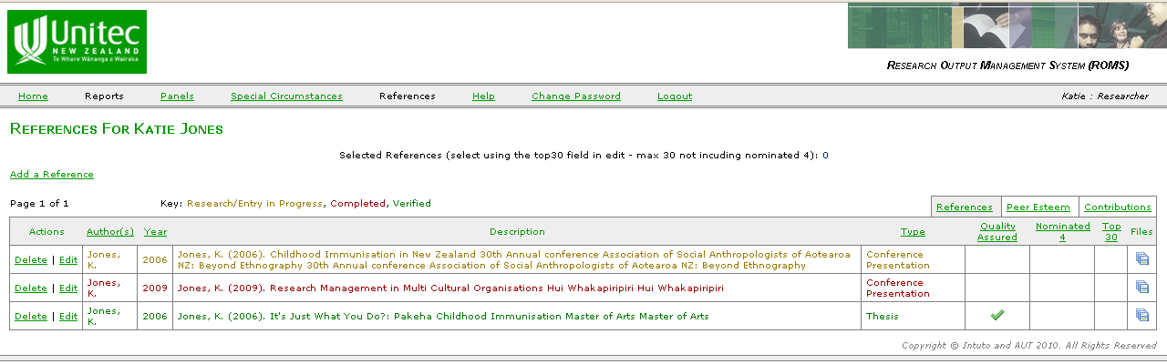
Add

On the top right hand of the table above, you will note there are three tabs – References, Peer Esteem and Contributions. These tabs take you to the relevant pages which permit you to enter and maintain your research outputs and activities.

Currently, the References tab is the page you are in. Clicking the Peer Esteem or Contributions tab will take you to the PE and CRE pages.

The References page is also colour coded so you know where your outputs are in the workflow process.
Yellow: Entry is currently in progress, and is not yet ready for verification.
Red: Output has been completed and is waiting on verification.
Green: Output has been verified by the Faculty and will appear in reports.

1.1.1 To Add New Research Outputs

From the References page, click Add a Reference (see above figure). This will bring up the following.

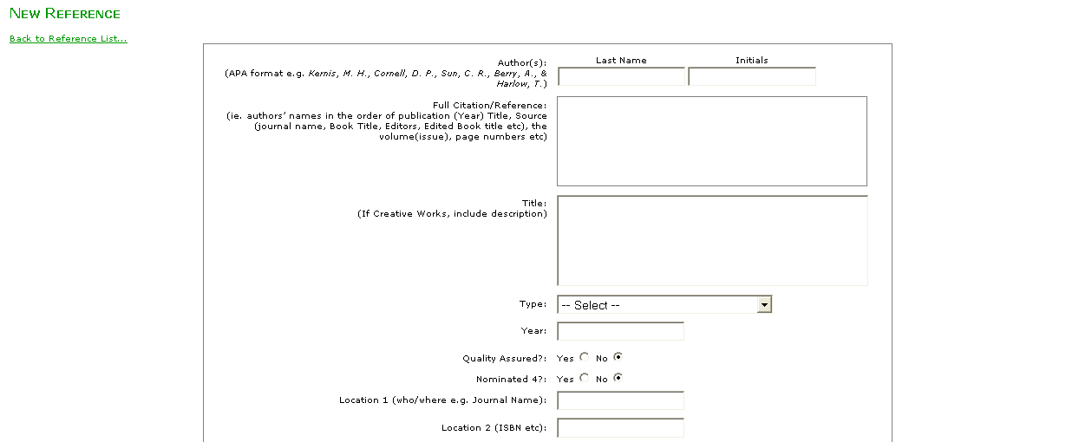
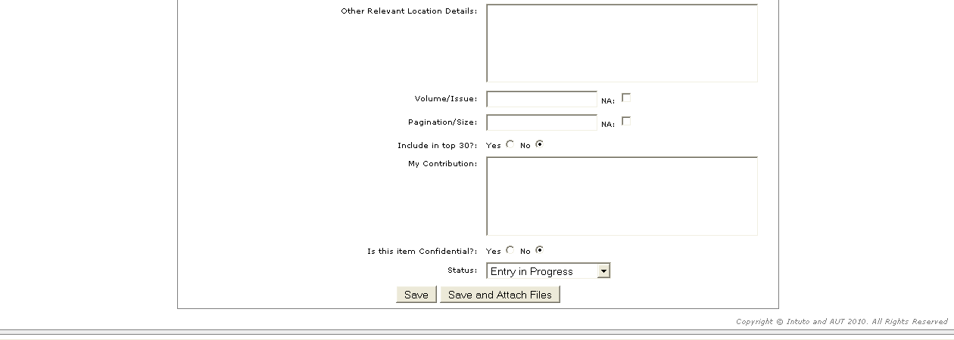

Important Note: You need to assign one of three statuses to your research output before saving your entry – please read the Status explanation below carefully. Entry-in-Progress (as shown above is the default status).

Status Select Entry-in-Progress if you have not completed entering all details of a published output. This allows you to edit the record later.

Select Entry Completed once you have completed entering all details of a published output and attached the evidence needed to verify the output. As such, you will not be able to edit this record subsequently. Contact your department ROMS representative if you need to amend the record. Please produce the evidence for verification. At least one file needs to be attached in order to select Entry Completed. Additional files can be attached once the status has been changed.

Select Research-in-Progress if output is yet to be published. For example, a forthcoming publication or a paper undergoing review (please identify outlet).

Author(s) As listed in and in the order of the publication. Additional author spaces will appear automatically.

Full Citation Full reference of the publication will automatically generate (in modified APA format)
/Reference (ie. authors’ names in the order of publication (Year) Title, Source (journal name, Book Title, Editors, Edited Book title etc), the volume(issue), page numbers etc.). This feature is under development and changes will be made periodically.

For example:
Chung, J. & Tan, F.B. (2004) Antecedents of Perceived Playfulness: An Exploratory Study on User Acceptance of General Information-searching Websites. Information and Management, 41(7), p. 869-881.

Title The full title as per the publication. If creative works, include description.

Type Select the publication type – i.e. journal, conference proceedings, exhibition
See Appendix 1 for the research output types.

Year The year when the outputs is publicly available (in print or online).

Quality Assured Whether the output is Quality Assured: Y = Yes / N = No
Y = Any research output that has successfully completed a formal quality-assurance process prior to its production (publication, public dissemination, presentation, performance, or exhibition).
N = Any research output that:
• has not been subject to a quality-assured process
• is currently in the process of being quality assured
•has been unsuccessful in completing a formal quality-assurance process (ie. it has been peer-reviewed and rejected)

Nominated 4 Whether the output is one of your Nominated Research Output
This is PBRF specific. You do not need to make nominations at this point.

Location 1 This field is output type specific. Refer to the Research Output Type Quick Reference Guide for further information.

Location 2 This field is output type specific. Refer to the Research Output Type Quick Reference Guide for further information.

Other Location This field is output type specific. Refer to the Research Output Type Quick Reference Guide for further information.

Volume/Issue Volume/Edition and issue of publication, where relevant

Pagination/Size Page numbers (journal or conference papers) or number of pages (book or report, where relevant.

Include Top 30 Whether the output is one of your top 30 research outputs
This is PBRF specific. You do not need to decide at this point.

My Contribution Describe how you have contributed to the research output
This field can also be used to include additional information about the output.
This is PBRF specific. You only need to complete this if output is one of your Nominated 4.

Is this item Defaults to No. If the item is confidential and should not be listed in reports
Confidential? Select Yes.
This information will still appear in your official PBRF portfolio, however it will not be listed elsewhere.

Save and Select this to save your record and upload your research (digital) objects to Attach Files the record. See the Research Output Type Evidence Guide for more
information on the types of evidence required for each output.
This allows you to further profile your research outputs.

1.1.2 To Edit Research Outputs Already Entered

From the References page, clicking Edit against the research output you wish to change brings up the following. You are now able to edit and save changes to the selected research output.

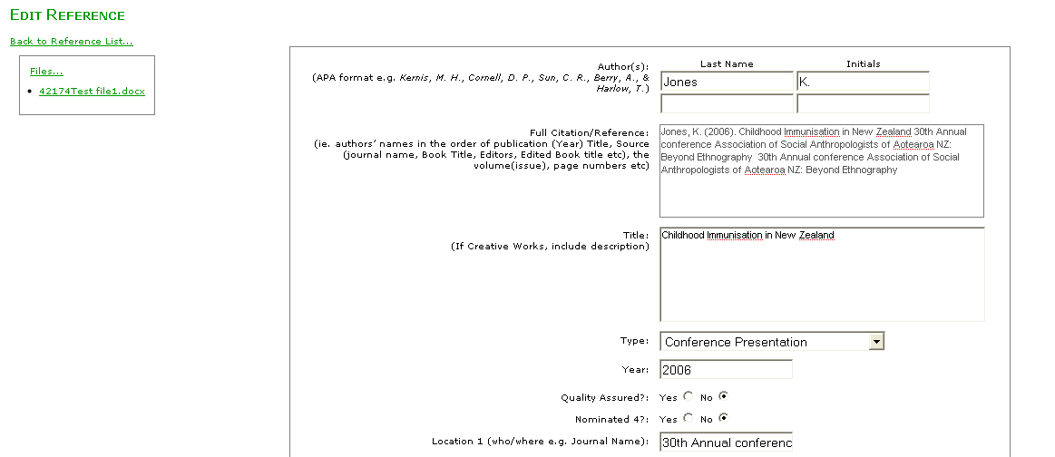

Note: You are only able to edit a record in Entry-in-Progress or Research-in-Progress status. If the research output is already in Entry Completed status, you will need to contact your department ROMS representative for assistance.

Click Save and Attach (scroll to bottom of page) to save changes.

1.1.3 To Upload Research (Digital) Objects/Files

From the New Reference page, selecting the Save and Attach Files button (at the bottom of the page) OR from the Edit Reference page, selecting Files (top left corner of page below the page titles) or the Save and Attach Files button (at the bottom of the page) brings up the following.
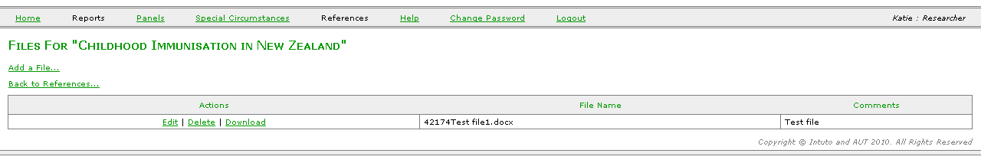
Add
Then, clicking Add a File, brings up the following page.

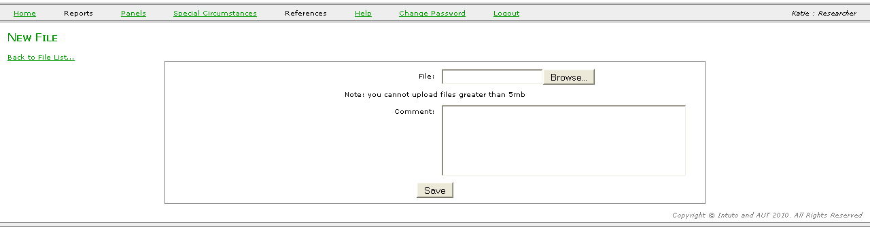
Browse To select the file

Comments Enter any comments about the file

Save To upload the file

Please note, you are not permitted to upload a file greater than 5mb. If the system does not permit you to upload the selected file, try uploading the file in a .zip format.

NOTE: You will not be able to change the Status of any new output to ‘Completed’ until a file has been attached.

1.2 Peer Esteem

Selecting the Peer Esteem tab brings up the following. New entries can be added or existing entries edited (Edit).
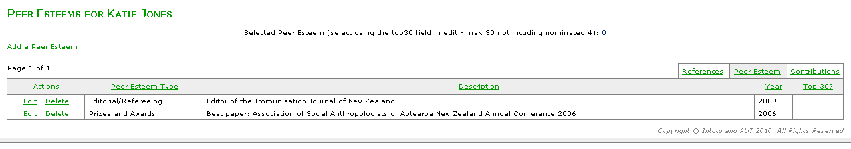
Add
Edit

1.2.1 To Add New Peer Esteem

Selecting Add a Peer Esteem will bring up the following.

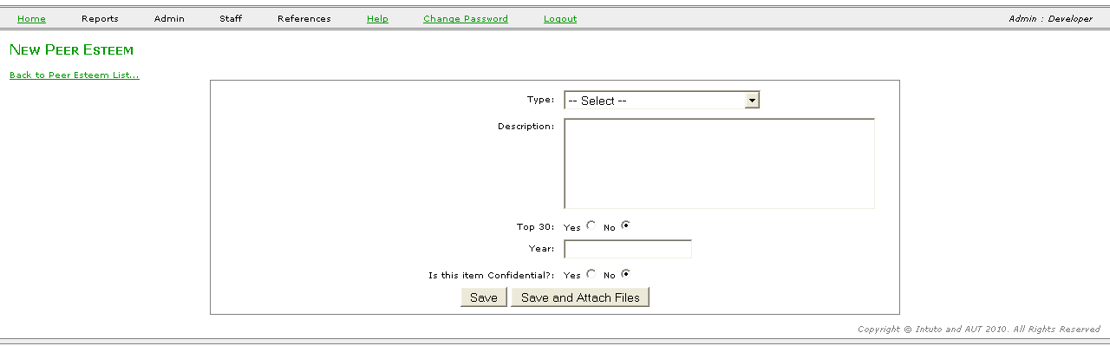

Type There are 9 types of Peer Esteem (see Appendix 2 for an explanation)
Description Outline the nature of the peer esteem item (max 255 characters)
Top 30 Defaults to No. Select Yes, if this is to be included in your top 30 PE items
Year Year in which the peer esteem item is to be recorded against. If the Peer Esteem runs over multiple years then place this information in the Description box.
Is this item Defaults to No. If the item is confidential and should not be listed in reports
Confidential? Select Yes.
Save To save the entry
Save and Attach Files Select this to save your record and upload your output (digital) objects to the record. This allows you to attach evidence for your Peer Esteem.

1.2.2 To Edit an Existing Peer Esteem

Selecting Edit against a Peer Esteem item from the list of Peer Esteems will bring up the following.
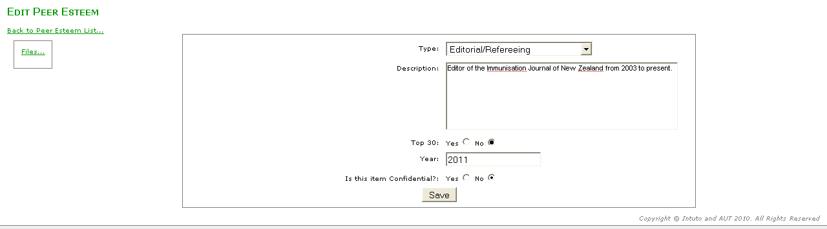

You are now able to edit the selected Peer Esteem record. Additional files can be added by clicking on the Files… button at the left of the screen.
Click Save to save the amended record.

1.3. Contribution to Research Environment

From the Menu tab, selecting Contributions brings up the following. New entries can be added or existing entries edited (Edit).
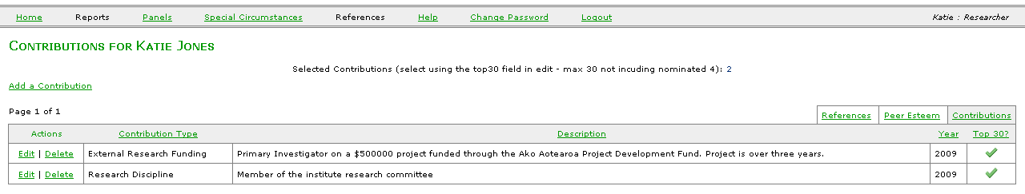
Add
Edit

1.3.1 To Add New Contribution

Selecting Add a Contribution will bring up the following.

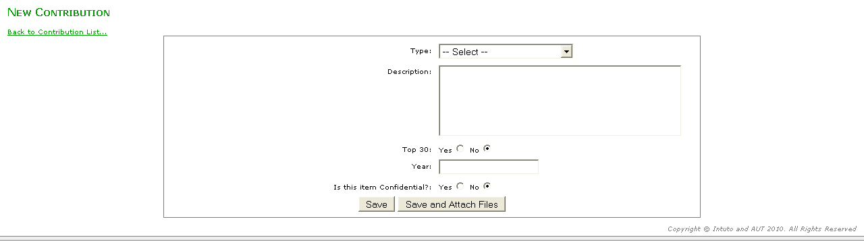
Type There are 9 types of Contributions (see Appendix 2 for an explanation).
Description Outline the nature of the Contribution (max 255 characters).
Top 30 Defaults to No. Select Yes, if this is to be included in your top 30 PE items.
Year Year in which the peer esteem item is to be recorded against. If the Peer Esteem runs over multiple years then place this information in the Description box.
Is this item Defaults to No. If the item is confidential and should not be listed in reports
Confidential? Select Yes.
Save To save the entry.
Save and Attach Files Select this to save your record and upload your output (digital) objects to the record. This allows you to attach evidence for your Peer Esteem.

1.3.2 To Edit an Existing Contribution

Selecting Edit against a Contribution from the list of Contributions will bring up the following.

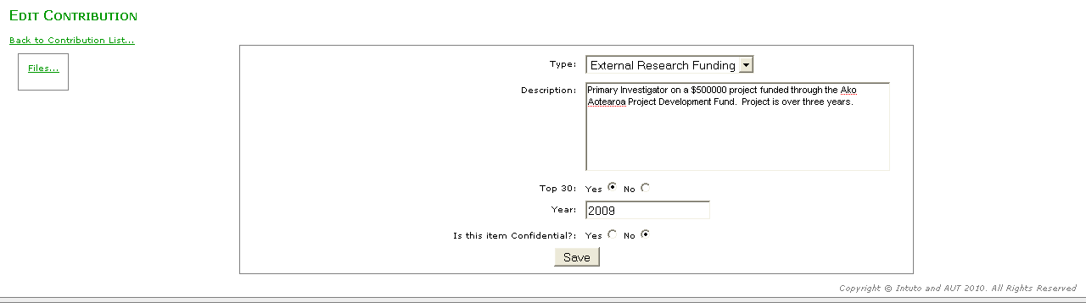
You are now able to edit the selected Contribution.
Click Save to save the amended record.

1.4 Reports

Your research outputs and activities can be viewed and printed by mousing over Reports on the Menu Bar and selecting Yearly Reports.

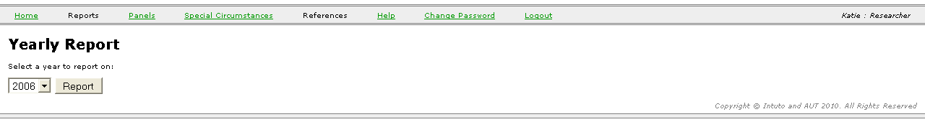

Select the year and then click Report to generate the report. You can either open the report on-screen or save to disk.

Data entered is saved into a database. Faculty and Institute administration can view all inputs and check all information recorded. Research outputs entered will need to be verified by your Faculty.

Section 2 – Preparing your PBRF Evidence Portfolio (EP)

There are 3 parts to a PBRF EP:
- Research Outputs (4 NROs + 30 Other Outputs)
- Peer Esteem (30 PE Items)
- Contributions to Research Environment (30 CRE items)

As indicated in Section 1, research outputs reported and verified in 2006-2009 have been uploaded onto the ROMS. As these records have been reported and verified, they are all “locked-down” (i.e. you will not be able to edit these records).

The Research Office will “unlock” all records so that you are able to prepare your PBRF EP. This will only be done when a PBRF round or an internal trial round occurs.

Details about PE and CRE components (i.e. what do PE and CRE cover? what are the types of PE and CRE) are provided in the Appendix 2. Please read the appendix carefully.

  - Selecting the Nominated Research Outputs

From the Menu Bar, mouse-over References and then selecting My Research Outputs will bring up the following.

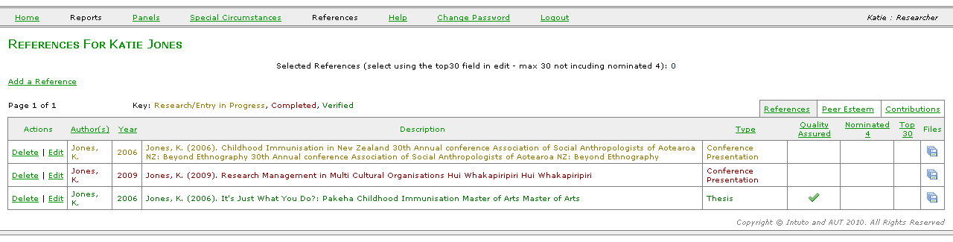
To select your 4 NROs, you will need to Edit the research outputs you wish to include as one of your top 4 in the Nominated 4 column.

On the Edit Reference page, check Yes against Nominated 4? option.

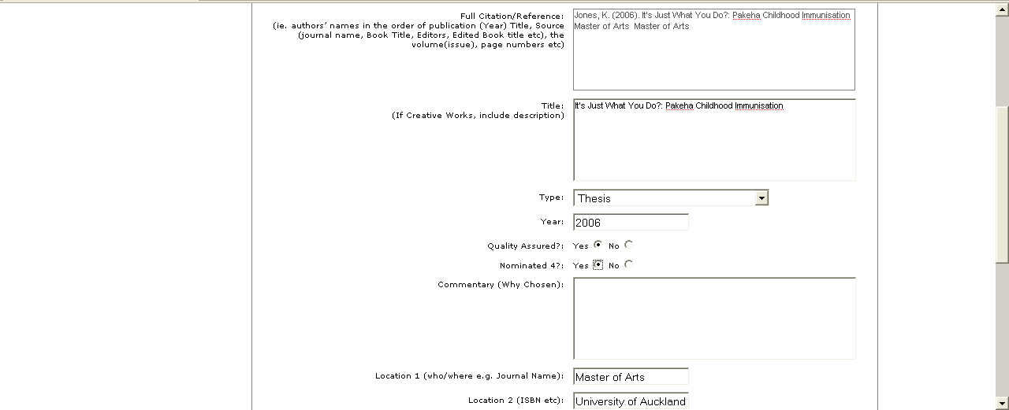
NRO

For each of the selected NRO, you will need to describe how you have contributed to the work and why you consider this as one of your top 4 research outputs for the PBRF period. A commentary box will appear automatically.

Please refer to Section 1.1 for a description of the fields in the above screen. The two fields that need to be carefully completed on this page are:

Commentary Describe why you have chosen the research output as one of your best.
(Why Chosen) Limited to 600 characters.

My Contribution Describe how you have contributed to the research output.

  - Editing and Ranking the Nominated Research Outputs

From the Menu Bar, mouse-over References and then selecting View/Edit Nominated 4 will bring up the following. There will be no entries on this page if you have not selected the 4 NROs (see previous section).

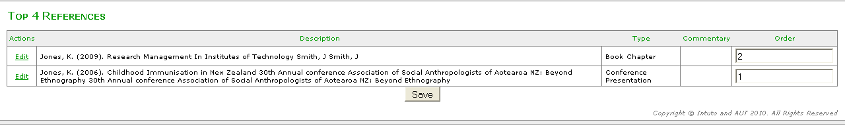
Clicking Edit against the selected NRO will then bring up the screen where further details can be added.

The order NROs appear in a portfolio can be changed by typing the number order for the selected NRO in the Order column.

  - Selecting the Top 30 Research Output Items

Referring to point 1.1.2 in Section 1, select Edit against the Research Output record you wish to include as one of your Top 30 Research Output items. This will bring up the screen in Section 1.1.2. Against the option Top 30, select Yes against the records you wish to include as your Top 30 Research Outputs.

  - Selecting the 30 Peer Esteem Items

Referring to point 1.2 in Section 1, select Edit against the PE record you wish to include as one of your 30 PE items. This will bring up the screen in Section 1.2.2. Against the option Top 30, select Yes against the records you wish to include as your 30 PE items.

  - Selecting the 30 Contribution to Research Environment Items

Referring to point 1.3 in Section 1, select Edit against the CRE record you wish to include as one of your 30 CRE items. This will bring up the page in Section 1.3.2. Against the option Top 30, select Yes against the records you wish to include as your 30 CRE items.

  - Panels

You are required to select a Panel to which your EP will be submitted. You will also need to select the Subject Area within the chosen Panel. See Appendix 3 for the list of Peer Review Panels and Subject Areas. Refer to the 2012 PBRF Guidelines and Manual for Researchers for details.

To select these, from the Menu Bar, click Panel and the following will appear.

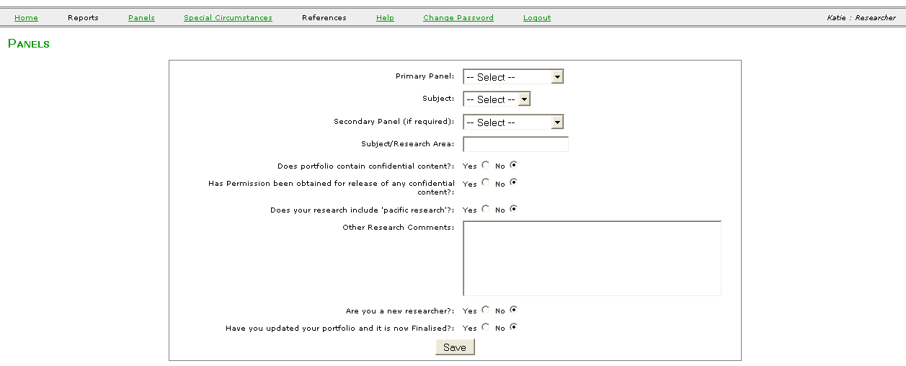

Primary Panel Select from the drop down menu the Panel to which your EP will be submitted. If you are unsure, please consult the Head or Chair of your Department or Research Committee.

Subject Select from the drop down menu the Subject Area within the chosen Panel.

Secondary Panel Only if required.

Subject or Enter a short description of your subject or research area.
Research Area e.g. Consumer Behaviour or Information Systems Management.

Does portfolio contain Check Yes or No.
confidential content?

Has permission been Check Yes or No.
obtained for release of
any confidential content?

Does your research Check Yes or No.
Include ‘pacific research’?

Other Research Describe broadly your research.
Comments

Are you a new Check Yes or No
researcher? This relates to eligibility as a New and Emerging Researcher.

Have you updated your Check Yes or No
portfolio and it is now Selecting Yes means your EP is ready to be submitted to the TEC.
finalised?

Save Saves your entry on this page.

  - Special Circumstances

Special circumstances can be claimed by a staff member and considered by the peer review panel only in relation to the quantity of research outputs and other aspects of research activity produced during the assessment period.

Special circumstances relate to some event that has affected the development of research outputs and the staff member’s PE or CRE components.

See Appendix 4 on how to deal with special circumstances. Refer to the 2012 PBRF Guidelines and Manual for Researchers for details.

To enter special circumstances, from the Menu Bar, click Special Circumstances and the following will appear.

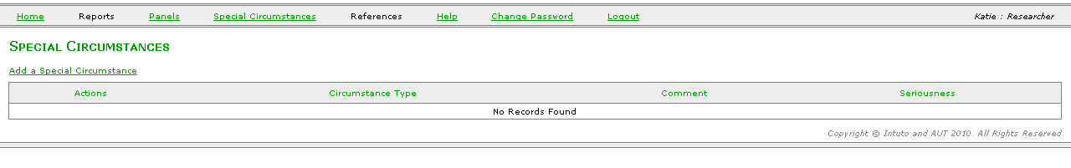

Then, select Add a Special Circumstance:

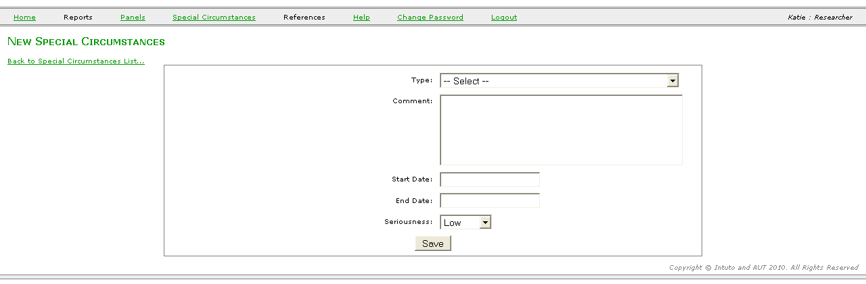

Type Select from the drop down menu the Special Circumstances type
See Appendix 4 for details.

Comment Describe the special circumstance being claimed.

Start Date State when the special circumstance commenced.

End Date State when the special circumstance ended.

Seriousness Select from the drop down menu the magnitude of the impact of the claimed special circumstance on the quantity of research outputs and other aspects of research activity produced during the assessment period.
Appendix 1: Research Output Types

Research outputs may be one of the following types:
Book Authored
Book Edited
Book Chapter
Book Review
Conference Abstract
Conference Poster
Conference Presentation
Conference Proceedings
Composition
Creative works
Design Output
Educational Material
Encyclopaedia Entry
Essay (published)
Exhibition solo
Exhibition group
Film/video
General Media (newspapers etc)
Intellectual Property
Interview – audiovisual
Interview – print
Journal Paper
Journal Other (letters, editorial etc)
Monograph
Performance
Plays
Presentation (non-conference)
Report
Scholarly Work
Software
Thesis
Working Paper (published)
Other Form of Assessable Output (including but not limited to new materials, structures, devices, images, products, buildings, food product and processes, internet publication, published geological and/or geomorphological maps, and explanatory texts)

Appendix 2

Peer Esteem and Contributions to Research Environment

What is Peer Esteem?

Introduction | In the PBRF, peer esteem is used as an indicator of the quality of the staff member’s research. It is concerned with the recognition of the staff member’s research by her or his peers, rather than esteem for other activities within the TEO, their subject area or the academic community.
Peer esteem indicators | Indicators of peer esteem include:  - Research-related fellowships, prizes, awards, invitations to share research knowledge at academic and end-user conferences and events.  - The ability to attract graduate students or to sponsor students into higher-level research qualifications, positions or opportunities because of his or her research reputation.  - Research-related citations and favourable review. In considering the former, note that the number of citations is not necessarily an indication of high esteem. Some research work may be cited frequently because it is considered to be an example of poor research. Emphasis should be given to evidence of positive review and citation.  - Participation in editorial boards.

Peer Esteem Types
Nine types | - Research-related fellowships, prizes and awards  - Fellows and/or restricted or elected membership of learned societies or academies  - Participation in editorial boards and/or refereeing (e.g. for journals)  - Invitations to provide conference addresses or similar  - Favourable reviews and/or commendations  - Appointments to key discipline-based, research, industry, professional, community or government bodies  - Esteem factors associated with students  - Research-related favourable citations  - Other evidence of peer esteem.  See below for detail

Prizes and awards | Prizes and awards include any prize, award attached to a specific research output or research activity or finding. It may also include a prize or award that reflects on the overall quality and productivity of a staff member rather than being attached to a specific research output, activity or finding.  The research fellowships under this type are those associated with research institutions. The research institution may be within New Zealand or elsewhere.
Fellows/ memberships | Fellowships/memberships may be to professional or learned societies or academies in New Zealand or elsewhere with restricted or elected admission. The expectation is that the esteem with which the staff member’s research activities is held would be a key component of the appointment to a fellowship or restricted/elected membership of the cited societies, academies or professional organisations.
Editorial/ refereeing | Editorial/refereeing includes editorship or membership of editorial panels of journals within New Zealand or elsewhere, reviewing and/or refereeing journal submissions and book proposals.
Conference addresses | Conference addresses includes invitations as a speaker to conferences/events in New Zealand or elsewhere.  Conferences and events may be discipline-based, academic or focusing on a substantive area of applied knowledge.
Favourable reviews | Favourable reviews may include review articles or professional comments, letters of commendation etc.
Appointments | Appointments may include appointment to New Zealand or overseas bodies or advisory bodies to industry, a profession, community, government or international bodies. They may also include appointment to research selection and funding bodies or committees, selection onto iwi boards, associations and preparation of claims to the Waitangi Tribunal. Appointment to statutory or non-statutory boards may also be relevant.
Student factors | Student factors may include examples of the staff member’s ability to attract graduate and/or overseas students or to mentor students into higher-level research qualifications, positions or opportunities because of his or her research reputation, and/or ability to attract quality students into graduate research.  Indicators may include citing students that the staff member has been able to sponsor into doctoral scholarships or postdoctoral fellowships because of the staff member’s research reputation. This may not be relevant for all subject areas.
Favourable citations | Favourable citations include descriptions and bibliographic references for citations of particular research outputs or bodies of research work that demonstrate the esteem within which their work is held by other researchers. Such citations do not need to show agreement with the research findings, but should show that the research is regarded as credible and significant.
Other | The Other peer esteem type may include other examples not included in the above types that demonstrate esteem, recognition or acknowledgement of the staff member’s research by peers, end users etc in the staff member’s own institution, within New Zealand and/or elsewhere.  This might include an ability to attract and/or host esteemed researchers or decision makers to visit their TEO or New Zealand; invitations to mentor; invitations to peer review; gaining competitive access to major national or international facilities and/or invitations to work in overseas institutions; or act in a quality assurance role in relation to other research activities, processes or policies.

Information on Peer Esteem Required in the EP
Up to 30 examples | Staff members are limited to providing 30 examples of peer esteem during the assessment period on their EP, classified under the types listed above. The peer esteem examples do not need to fall across all the different types but could be concentrated on one or a few of the types.  Where a staff member has more than 30 examples, they should concentrate on providing the most significant examples of peer esteem and those that best reflect the research-related esteem of their peers.
Extended description of example | In some instances, the information that a staff member wishes to include in the EP about an example may exceed the character limit of the Description field for that example. The staff member can choose to continue the information in the Description field immediately below (choosing the same peer esteem type), but this will reduce the number of individual examples that can be included in the EP to 29 (or less depending on the number of description fields used to provide the information for that example).
Description of peer esteem examples | For every example of peer esteem included in the EP, the staff member should provide a description that includes the following information:  - Details of the esteem example (e.g. prize, award, favourable review, appointment)  - Date(s), where relevant  - Organisation(s) involved.
Major prizes outside assessment period | Staff members may include major prizes and awards from outside the assessment period where these are research-related, but the panel will give primary weight to those peer esteem examples that have been gained within the assessment period.  Where the award or fellowship is ongoing (e.g. fellowship of learned society), these can be included in the EP, even though the appointment to that was outside the assessment period. For example, appointment as a Fellow of the Royal Society in 1994 can be included as a peer esteem example for the 2003 Quality Evaluation if the fellowship was held during the assessment period.

What is Contribution to the Research Environment?

Introduction | The contribution to the research environment component is concerned with the staff member’s contribution to a vital, high-quality research environment. Active research environments are a key outcome sought from the PBRF, and EPs provide an opportunity for staff members to indicate their role and contributions in this respect.

Contribution to the Research Environment Types
Nine types | - Membership of research collaborations and consortia  - Contributions to the research discipline  - Facilitating discipline-based and research networks  - Contributions to the research environment within and outside the TEO  - Generation of externally funded research  - Contribution to researcher development  - Supervision of student research  - Assisting student publishing, exhibiting or performance  - Other evidence of contribution to the research environment.  There is a particular emphasis on the contribution to and development of Maori and/or Pacific research capability.
Consortia membership | Consortia membership may include leadership or membership of research collaborations/consortia within the staff member’s TEO, within New Zealand or elsewhere.
Research discipline | Contribution to research discipline may be within the staff member’s TEO, within New Zealand or elsewhere.
Facilitating networks | Examples of facilitation networks include organising and/or hosting or chairing conferences, panels, seminars, workshops or similar events; developing working relationships amongst researchers within and across institutions and subject areas; developing and maintaining strong links with end users of research, including active engagement with relevant communities and stakeholders, and dissemination of research outputs.
Research environment | The research environment type includes the development of research infrastructure (facilities and otherwise) within the TEO and elsewhere in New Zealand.
External research funding | The external research funding type includes the staff member’s ability to contribute to a vital research environment and demonstrate a record of quality research through the attraction of funding external to the TEO. In exceptional cases, the research may not be funded but generated from external sources. The amount of funding received is not required as this is assessed for each participating TEO under the External Research Income measure.
Researcher development | Researcher development includes activities that contribute to the development of new researchers, such as those who have completed their degrees and are starting a research career, and contribution to research capability.
Student supervision | Student supervision includes the supervision of masters or doctoral-level students, including assistance to Maori students and Pacific students. Indicators may include citing students that the staff member has supervised.
Student assistance | Examples of contribution to student assistance include where the staff member has assisted a student under their supervision to publish, exhibit, participate in competitions (within New Zealand and overseas) or produce a research output, possibly in conjunction with academic staff.
Other | Other contributions to the research environment may include other examples not included in the above types that demonstrate the staff member’s contribution to research vitality in the staff member’s own TEO, within New Zealand and/or elsewhere.

Information on Contribution to the Research Environment Required in the EP
Up to 30 examples | Staff members are limited to providing 30 examples of contribution to the research environment during the assessment period on their EP, classified under the types listed above. The examples do not need to fall across all the different types but could be concentrated on one or a few of the types  Where a staff member has more than 30 examples, they should concentrate on providing the most significant examples of their contribution.
Extended description of example | In some instances, the information that a staff member wishes to include in the EP about an example may exceed the character limit of the Description field for that example. The staff member can choose to continue the information in the Description field immediately below (choosing the same contribution to the research environment type), but this will reduce the number of individual examples that can be included in the EP to 29 (or less depending on the number of description fields used to provide the information for that example).
Description of contribution to the research environment examples | For every example of contribution to the research environment included in the EP, the staff member should provide a description that includes the following information:  - Details of the activity  - Date(s), where relevant  - Organisation(s) involved  - Student numbers and the degree level (e.g. masterate, doctoral), where relevant.
Relation to assessment period | Evidence of contribution to the research environment should relate to the assessment period.  However a staff member may include examples of contribution to the research environment from outside of the assessment period if such contributions are outstanding or of particular significance.

Appendix 3

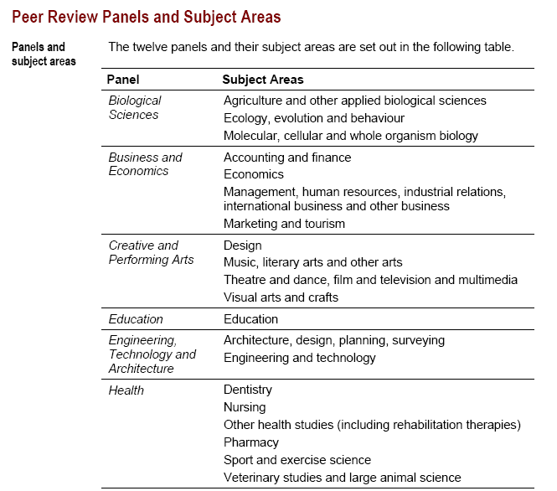
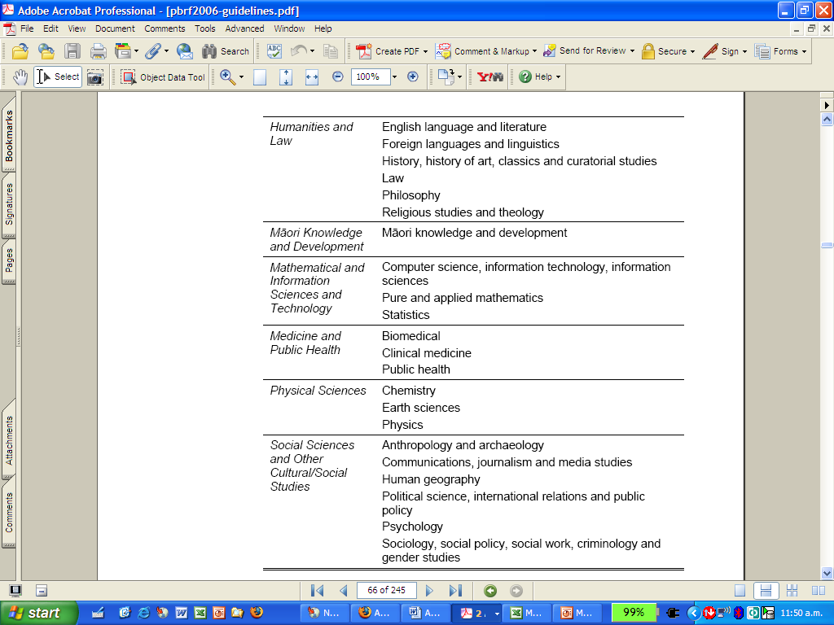

Appendix 4: Special Circumstances




